Experiment 1
Perform basic Image Handling and processing operations on the image.
• Read an image in python and Convert an Image to Grayscale

PROGRAM
import cv2
img = cv2.imread("tree.jpg")
if img is None:
print("Image not found!")
else:
gray = cv2.cvtColor(img, cv2.COLOR_BGR2GRAY)
cv2.imshow("Original Image", img)
cv2.imshow("Gray Image", gray)
cv2.waitKey(0)
cv2.destroyAllWindows()

INPUT
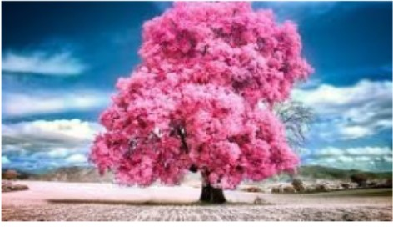
OUTPUT
